**COMMUNION STEPPING STONE**

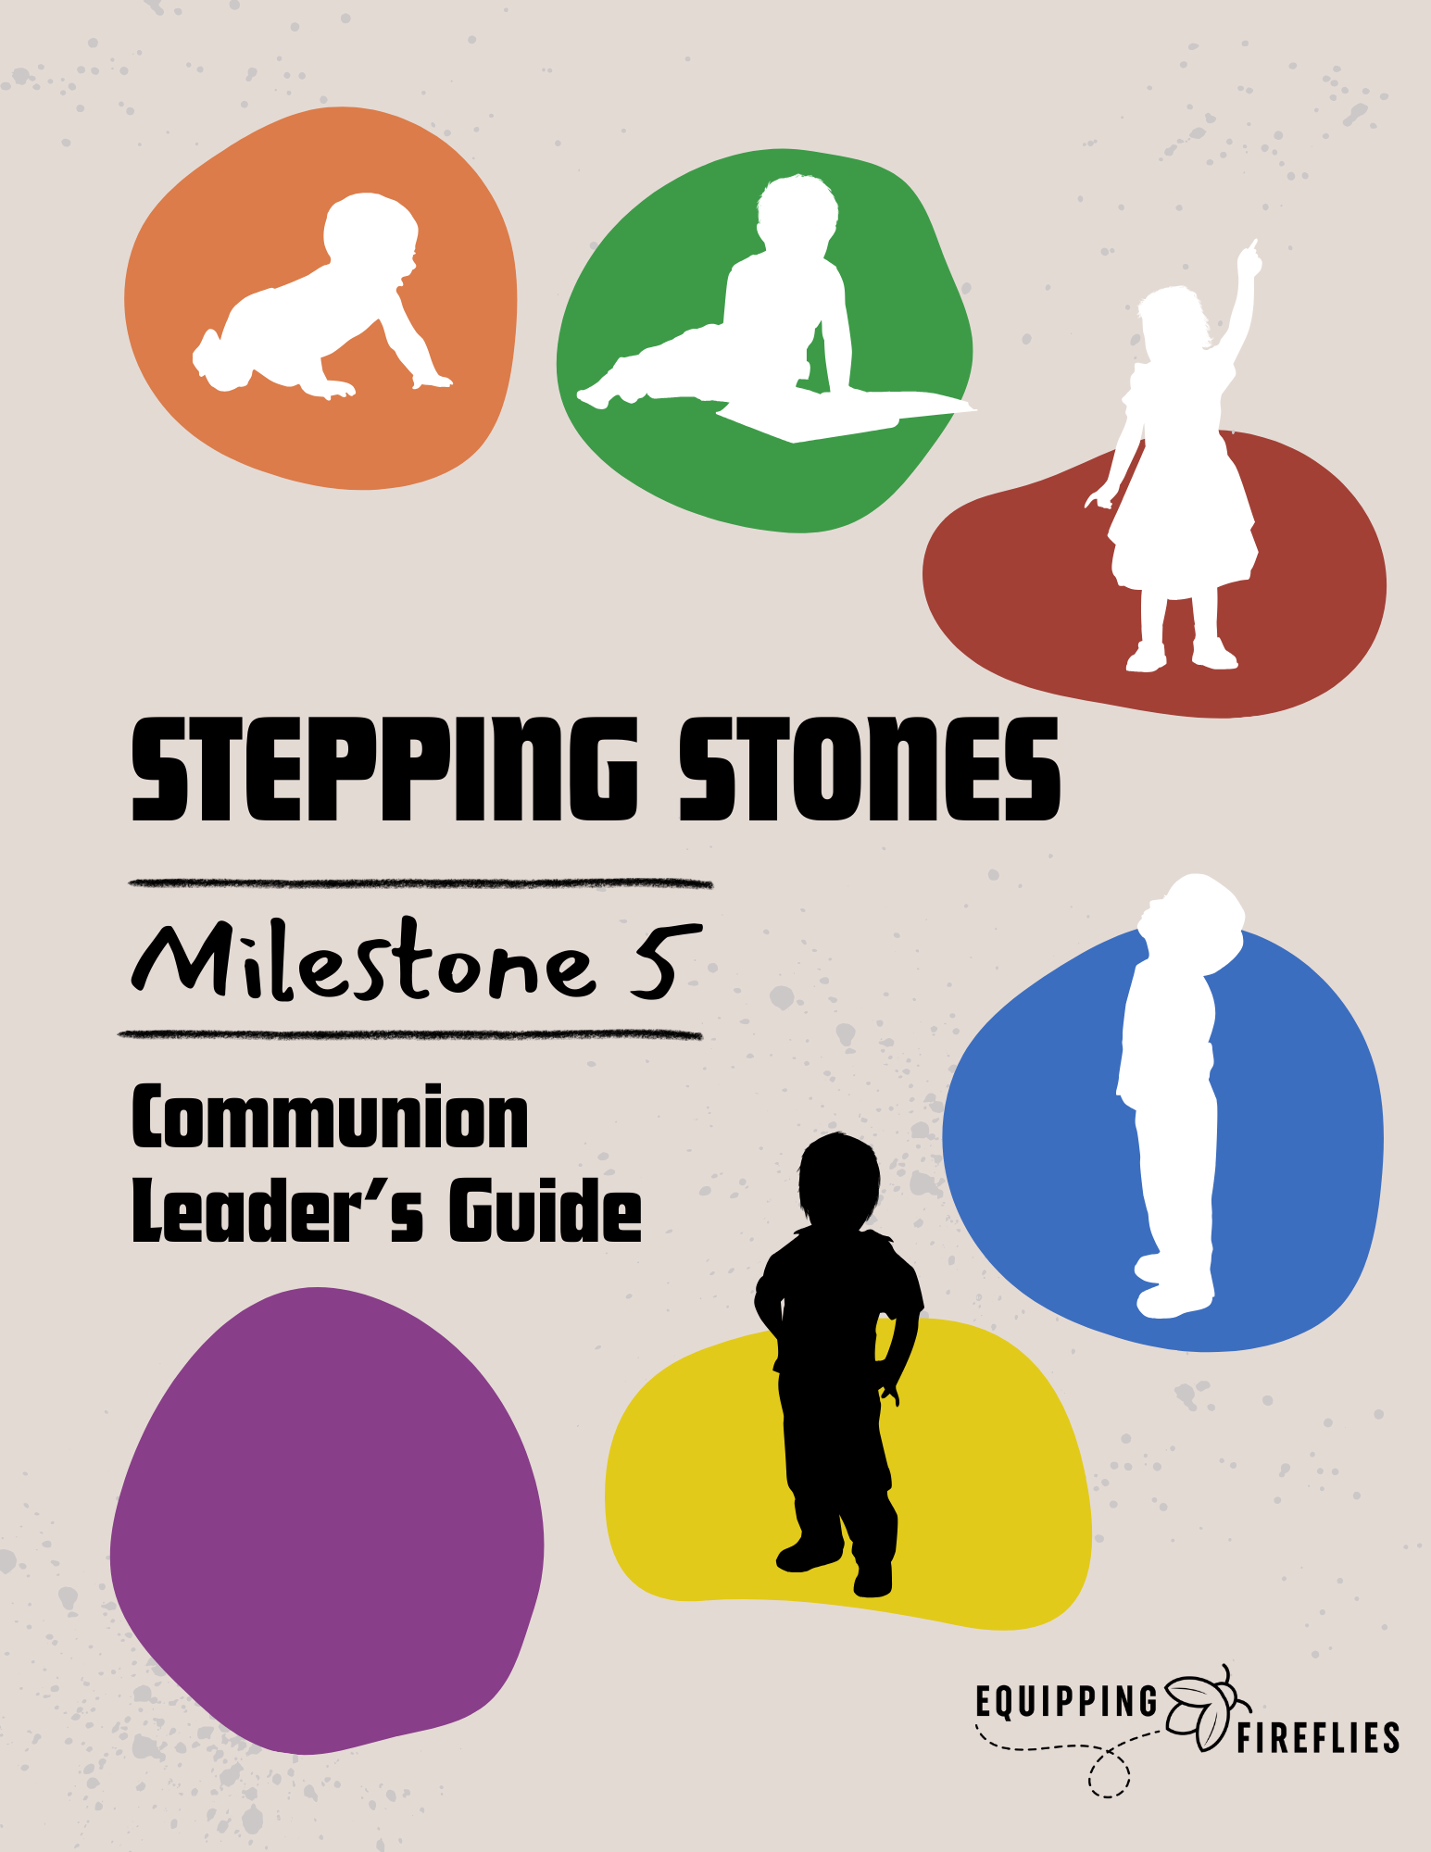

Written by Janine McNally (Equipping Fireflies)

**COMMUNION STEPPING STONE**

Dear Children’s Director,

The most important time in the lives of the children in your ministry is when they first trust in Jesus as their Savior.

Teaching about communion can help alleviate fears when a child has been baptized and is ready to take their first communion. It can be an encouragement, not only for the child but also for the parents. We must take advantage of every opportunity to connect with and equip parents. This is one of those milestone opportunities!

What is our goal for this class? We will cover the following:

**SESSION ONE – THE GOSPEL**

The Gospel

Bad News

1. I am a Sinner
2. The Penalty for Sin is Death

Good News

1. Jesus Died to Pay My Penalty
2. I Can Be Saved Through Faith

**SESSION TWO – HOW TO BE SURE OF YOUR SALVATION**

**Estimated Class Time:** 2 hours (depending on optional activities used).

**EQUIPPING FIREFLIES STEPPING STONES CLASSES**

Big moments in life—rites of passage—milestones—are important in our children's lives, yet we often commemorate such occasions with a passing “congratulations.” This is one of six Milestone classes that EQUIPPING FIREFLIES has developed to enable you to celebrate with the children in your ministry and encourage and equip their parents.

There is no better time to partner with parents than during these milestone occasions.

We have six different Milestone Classes available.

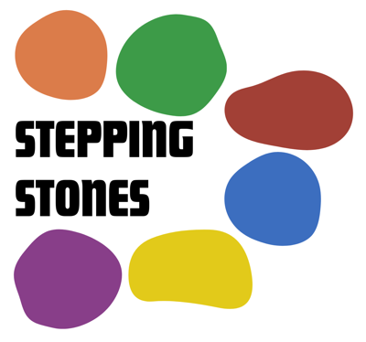

* [Parent/Child Dedication](https://www.grace4kidz.org/product/dedication)
* [Bible Presentation](https://www.grace4kidz.org/product/bible-presentation-class-complete)
* [Salvation](https://www.grace4kidz.org/product/salvation)
* [Baptism](https://www.grace4kidz.org/product/baptism)
* [Communion](https://www.grace4kidz.org/product/communion)
* [Graduation](https://www.grace4kidz.org/product/graduation)

Your purchase of each digital product provides you with an UNLIMITED LICENSE for your local church to print as many copies as you need. Your license never expires but is limited to one local church ministry.

Your complete STEPPING STONES package is available in electronic format as an instant download. It is provided in a Microsoft Word format, so you can customize the contents for your ministry as needed. Unless otherwise noted, all verses used are the New International Version (NIV).

**COMMUNION STEPPING STONES CLASS**

Thank you for purchasing our Communion Milestone Class.

The Communion Milestone is a class designed for kids and their parents to attend together. It is not designed to be a “drop off” session.

This is a one-session class designed for kids who are ready to learn and understand the meaning of Communion. It includes everything you need to explain its meaning and process.

One of the key times in a child’s life is the first time they take communion. This resource was created to help you encourage and equip children and their parents as they prepare for this special time.

This class is designed for 4th-5th grade children. If you plan to use it for younger children, you will probably want to modify the content a little.

**Delivered Electronically - Instant Download**

**Your complete package includes:**

* A Teacher's Guide (includes Discussion Questions) that prepares students for taking communion - the material is designed to engage kids and parents with activities, discussions, and hands-on learning.
* Parent's Guide containing the Small Group Discussion Questions and Answers.
* A Student Guide designed to allow families to follow along and keep it as a memento of the class.
* PowerPoint Presentation Slides (in pdf and jpg format).
* Advertising Slides to promote the class.
* Parent Letter.
* Baptism Class Invitation (if having a Baptism Class) ready to print.
* Faith Certificate Template (Print on cardstock).
* Gospel Bookmark Template (Print one per child on cardstock and laminate if possible).
* Full Media slides for your presentation (PDF and JPG files included).
* Promotional materials that are editable and ready to print.

**Additional Resources Included:**

* Sidewalk Gospel Activity (Print activity sheets and provide sidewalk chalk).
* Paper Airplane Activity (Print activity sheets).
* Gospel Bracelet Activity.
* Wordless Book Activity – Instructions and Explanation.
* Four different gospel posters (Select your preferred poster and print on 11x17” cardstock if possible. Use during class and display on the wall after class is complete).
* Assurance Poster (Select your preferred poster and print on 11x17” cardstock if possible. Use during class and display on the wall after class is complete).

**INSTRUCTIONS FOR USE**

* The Teacher and Student Notes should be copied on 8.5x11” paper and stapled together. Print a copy of the parent letter – one per family.
* Copy the Faith Certificate on white cardstock and be ready to personalize it with the child’s name and date. Purchase frames for each (optional).
* Print the baptism invitations on 8.5x11” cardstock and provide them to each family if you plan to follow up with a baptism service.
* Use the additional optional activities at your discretion.

**Class Materials Needed: (Additional)**

* Sign-in sheet.
* Name tags for parents and children.
* Music to play while families arrive and during small group activities.
* Pens/pencils – enough for each child.
* A gift to give away (should be a gift that both a boy and girl would like).
* Snacks and drinks (optional).
* Communion ingredients appropriate for your church (Optional)

This event is designed to last about an hour (depending on how long you allow for discussion times).

**ADDITIONAL SUGGESTIONS**

* The Bible Presentation Milestone is a class for children and their parents to attend together. It is intended for both children and their parents/guardians. It is not designed to be a “drop-off” session.
* A week before the class, ask the parents/guardians to choose a “life verse” to be included in the front of their child’s new Bible. If they don’t have one, pick one appropriate for them.
* Set up a photo backdrop and have a photographer take pictures of each family. Afterward, email them the pictures.

• Use round tables and chairs for seating if possible.

* Provide refreshments after the class or lunch before beginning to enable parents to connect with other parents.
* The class is designed to take two hours. If possible, it would be best to divide it into two one-hour sessions. However, you can shorten or lengthen it depending on whether you add or subtract material.