JANINE MCNALLY

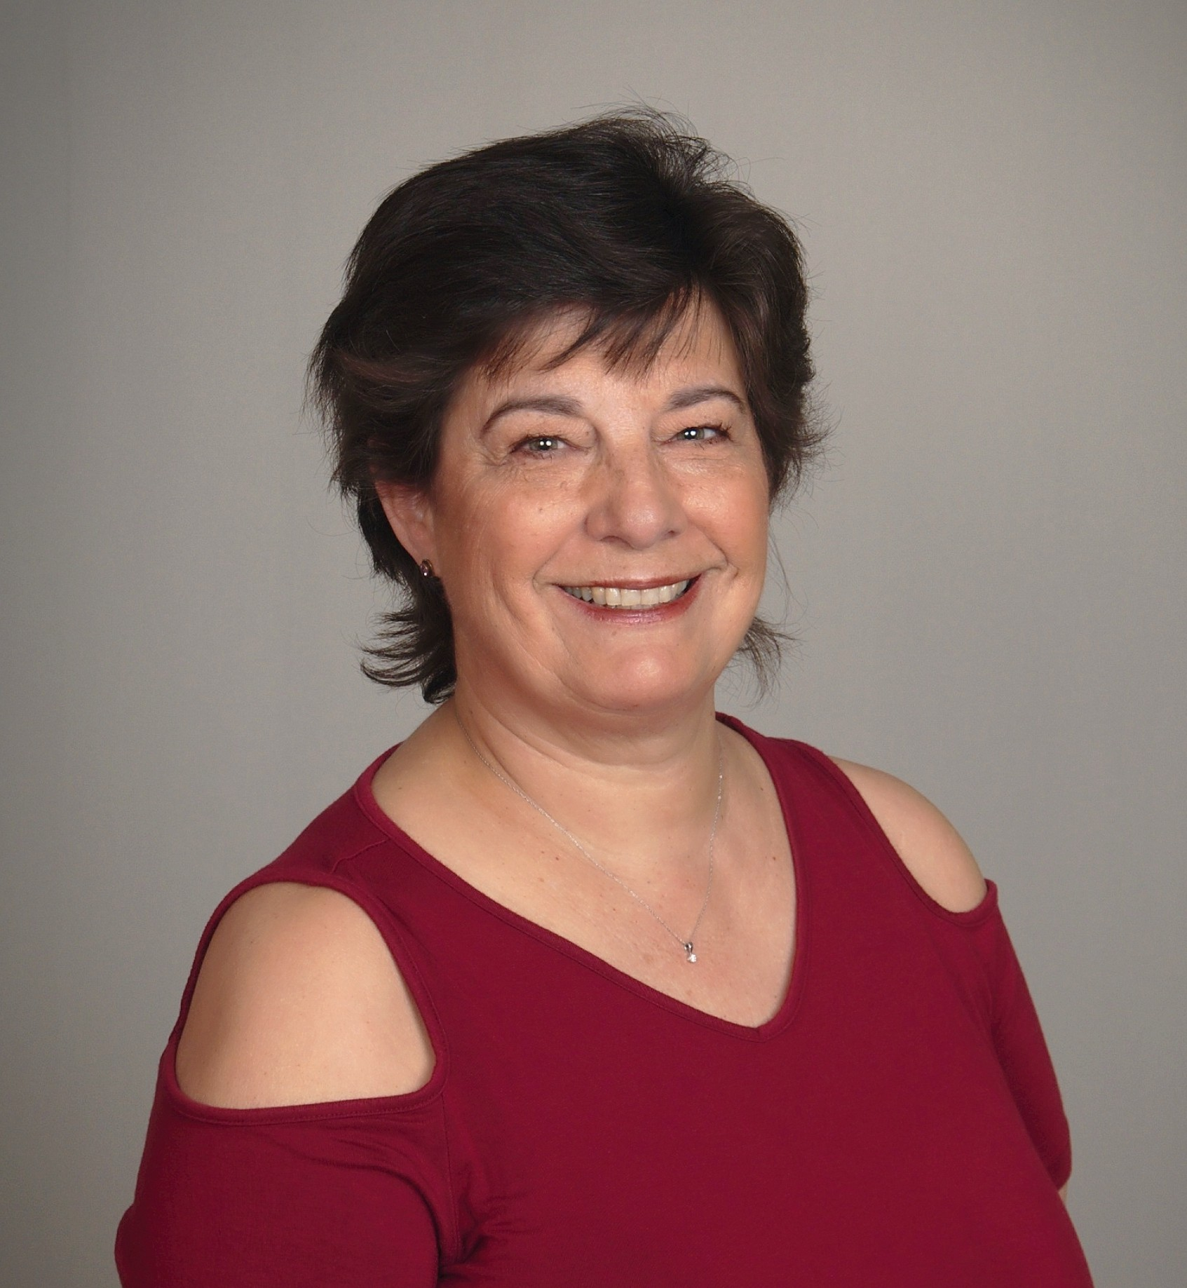
Short Bio
JANINEMCNALLY Passionate about today's children
Originally a high school teacher in her native Australia, Janine McNally has partnered with her husband for many years in pastoral and church-planting ministry. She graduated with a Master of Theology degree from Dallas Theological Seminary and her Doctor of Ministry degree from Grace School of Theology. She passionately believes in reaching kids for Jesus and enlightening leaders and parents about Generation Alpha.
Janine and Gary have been married for thirty years and live in Panama City, Florida. They are the parents of three grown children and three grandchildren. She directs the operations of Equipping Fireflies, a non-profit dedicated to providing gospel-centered resources for children."

Medium Bio
Originally a high school teacher in her native Australia, Janine McNally has partnered with her husband for many years in pastoral ministry. Janine graduated with a Master of Theology degree from Dallas Theological Seminary and her Doctor of Ministry degree at Grace School of Theology in Houston, TX.

Janine McNally is the founder and director of Equipping Fireflies, a nonprofit dedicated to producing quality gospel-centered resources for children’s ministry leaders and parents. In her spare time, she is an author, resource creator, curriculum writer, and adjunct Professor of Christian Education. She has authored thirteen books, including “When You See Fireflies,” “From Heartbreak to Healing,” the “Understanding Life” series (seven books) and “STEPS to Knowing Jesus.”

For over 40 years, she has been involved in women’s, youth and children’s ministry, pastoral ministry, and church planting alongside her husband. She passionately believes that now is the time to reach kids for Jesus and that children’s ministry is the most strategic ministry in the church.
Janine and Gary have been married for thirty years and live in Panama City, Florida. They are the parents of three grown children, Hannah (married to Kevin), Jonathan, and Jami, and three beautiful grandchildren (Grayson, Hunter and Emmy).


Long Bio
JANINEMCNALLY Passionate about today's children
Originally a high school Math teacher in her native Australia, Janine McNally moved to the United States to attend Dallas Theological Seminary. She graduated with top honors with her Master of Theology degree and her M.R.S. when she met and married her sweetheart. They moved around the country from New Jersey to Oregon and back, working in church planting and pastoral ministry for many years. Most recently, Janine served as Director of the Children’s Ministry at a church in Colorado.

In 2021, Janine began Equipping Fireflies, a non-profit company dedicated to producing quality gospel-centered resources for children, ministry leaders and parents. In her spare time, she is an author, resource creator, curriculum and blog writer, and adjunct professor of Christian Education at Grace School of Theology in Houston. TX. She has authored thirteen books, including “When You See Fireflies. Equipping Parents and Leaders to Minister Effectively to Generation Alpha,” “From Heartbreak to Healing – Finding Hope after the Loss of a Child,” the “Understanding Life” series (7 books) and “STEPS to Knowing Jesus.”

Janine has been involved in academic teaching for many years while she was in seminary.
She has led and taught youth and women’s ministry, as well as elementary through high school in home-school communities. She has spoken on many podcasts, Christian conferences, and seminaries. She passionately believes in reaching kids for Jesus and enlightening leaders and parents about Generation Alpha.

Gary and Janine have been married for thirty years and are the parents of three grown children: Hannah (married to Kevin Fordred), Jonathan, and Jami. They live in Panama City, Florida, where Janine writes and directs the operations of Equipping Fireflies.

Contact
Email: Janine@EquippingFireflies.com
Phone: 303-204-1244
Address: 250 E. 3rd Place, Panama City, FL 32401
www.JanineMcNally.com

