**BIBLE PRESENTATION STEPPING STONE**

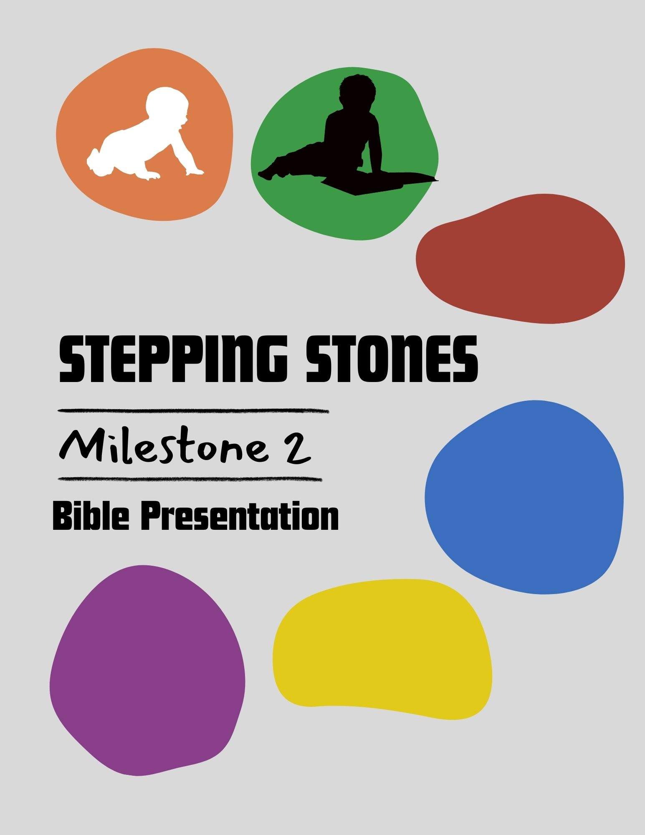

Written by Janine McNally (Equipping Fireflies)

**EQUIPPING FIREFLIES STEPPING STONES CLASSES**

Big moments in life—rites of passage—milestones—are important in the lives of our children, yet we often commemorate such occasions with a passing “congratulations.” This is one of six Milestone classes that EQUIPPING FIREFLIES has developed to enable you to not only celebrate with the children in your ministry but also encourage and equip their parents.

There is no better time to partner with parents than during these milestone occasions.

We have six different Milestone Classes available.

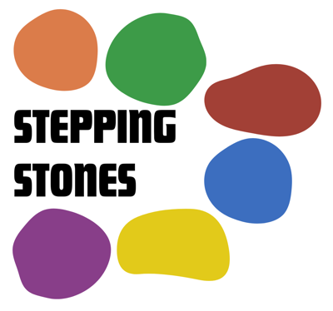

* [Parent/Child Dedication](https://www.grace4kidz.org/product/dedication)
* [Bible Presentation](https://www.grace4kidz.org/product/bible-presentation-class-complete)
* [Salvation](https://www.grace4kidz.org/product/salvation)
* [Baptism](https://www.grace4kidz.org/product/baptism)
* [Communion](https://www.grace4kidz.org/product/communion)
* [Graduation](https://www.grace4kidz.org/product/graduation)

Your purchase of each digital product provides you with an UNLIMITED LICENSE for your local church to print as many copies as you need. Your license never expires but is limited to one local church ministry.

Your complete STEPPING STONES package is available in electronic format as an instant download. It is provided in a Microsoft Word format, so you can customize the contents for your ministry as needed. All verses used are the New International Version (NIV) unless otherwise noted.

If you'd like to subscribe to keep informed of sales, giveaways, or new products as they arrive, please do so at EquippingFireflies.com.

Visit www.EquippingFireflies.com for a FREE eBook about Generation Alpha, the generation we are now ministering to.

Bible Presentation Stepping Stone

Dear Children’s Director,

One of the key times in the lives of the children in your ministry is when they reach the “reading” stage (or enter elementary school). Using this opportunity to present a Bible to each child can be a strategic time to celebrate with the family.

Taking the opportunity to teach about the Bible and how to read it can be helpful not only for the child but also as an encouragement for the parent. We must take advantage of every opportunity to connect with and equip parents. This is one of those milestone opportunities!

What is our goal for this class?

* To teach about the Bible - that it is “Inspired,” “Inerrant,” and “Preserved.”
* To explain the structure of the Bible, the types of literature, and the order of the books.
* To teach children how to find a specific verse.
* To show how Bible memory is critical in our spiritual growth.
* To demonstrate how to have a daily “Quiet Time” with God.
* To provide an opportunity to present the Gospel.
* To provide a special milestone celebration as children are presented with their first “big kid” Bible.
* To pray for both the child and the parents as they seek to train their children and provide a godly example for them to follow.

This class is designed to be presented over two separate sessions, or it can be combined with a lunch or snack break in between.

**This resource includes...**

* Postcard invitations you can edit for your ministry to invite parents to join their children for the Bible Presentation Class.
* A Teacher's Guide - the material is designed to engage kids and parents with activities, discussions, and hands-on learning.
* A Student Guide designed to allow families to follow along and keep it as a memento of the class.
* Bible presentation labels - for the inside cover of each gift Bible.
* Full Media slides for your presentation
* Books of the Bible Bookmark Template
* 3 Year Bible Reading Plan
* Bible Recommendation list

**ADDITIONAL SUGGESTIONS**

* The Bible Presentation Milestone is a class designed for kids and their parents to attend together. This class is intended for both children AND their parents/guardians. It is not designed to be a “drop off” session.
* A week before the class, ask the parents/guardians to choose a “life verse” to be included in the front of their child’s new Bible. If they don’t have one, pick one appropriate for them.
* Set up a photo backdrop and have a photographer take pictures of each family. Afterward, email them the pictures.
* Provide refreshments after the class or lunch before beginning to enable parents to connect with other parents.
* The class is designed to take two hours. If possible, divide the class into two one-hour sessions. However, you can shorten or lengthen it depending on whether you add or subtract material.